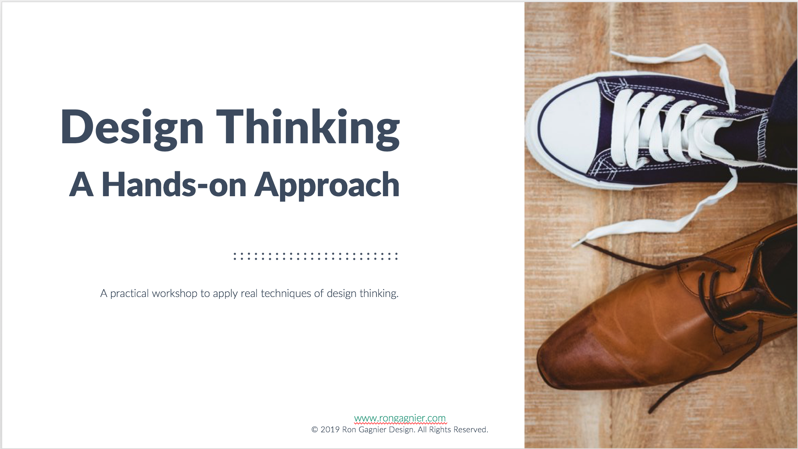

# Instructor Notes:

Like the real world, during the case study we will use today:

* You won’t have enough time
* You may not always know what to do
* You will have to make decisions
* You will have to work with others
* You will have to trust the process & others

Most importantly, you will have to put yourself in someone else’s shoes, to understand them, and their situation.

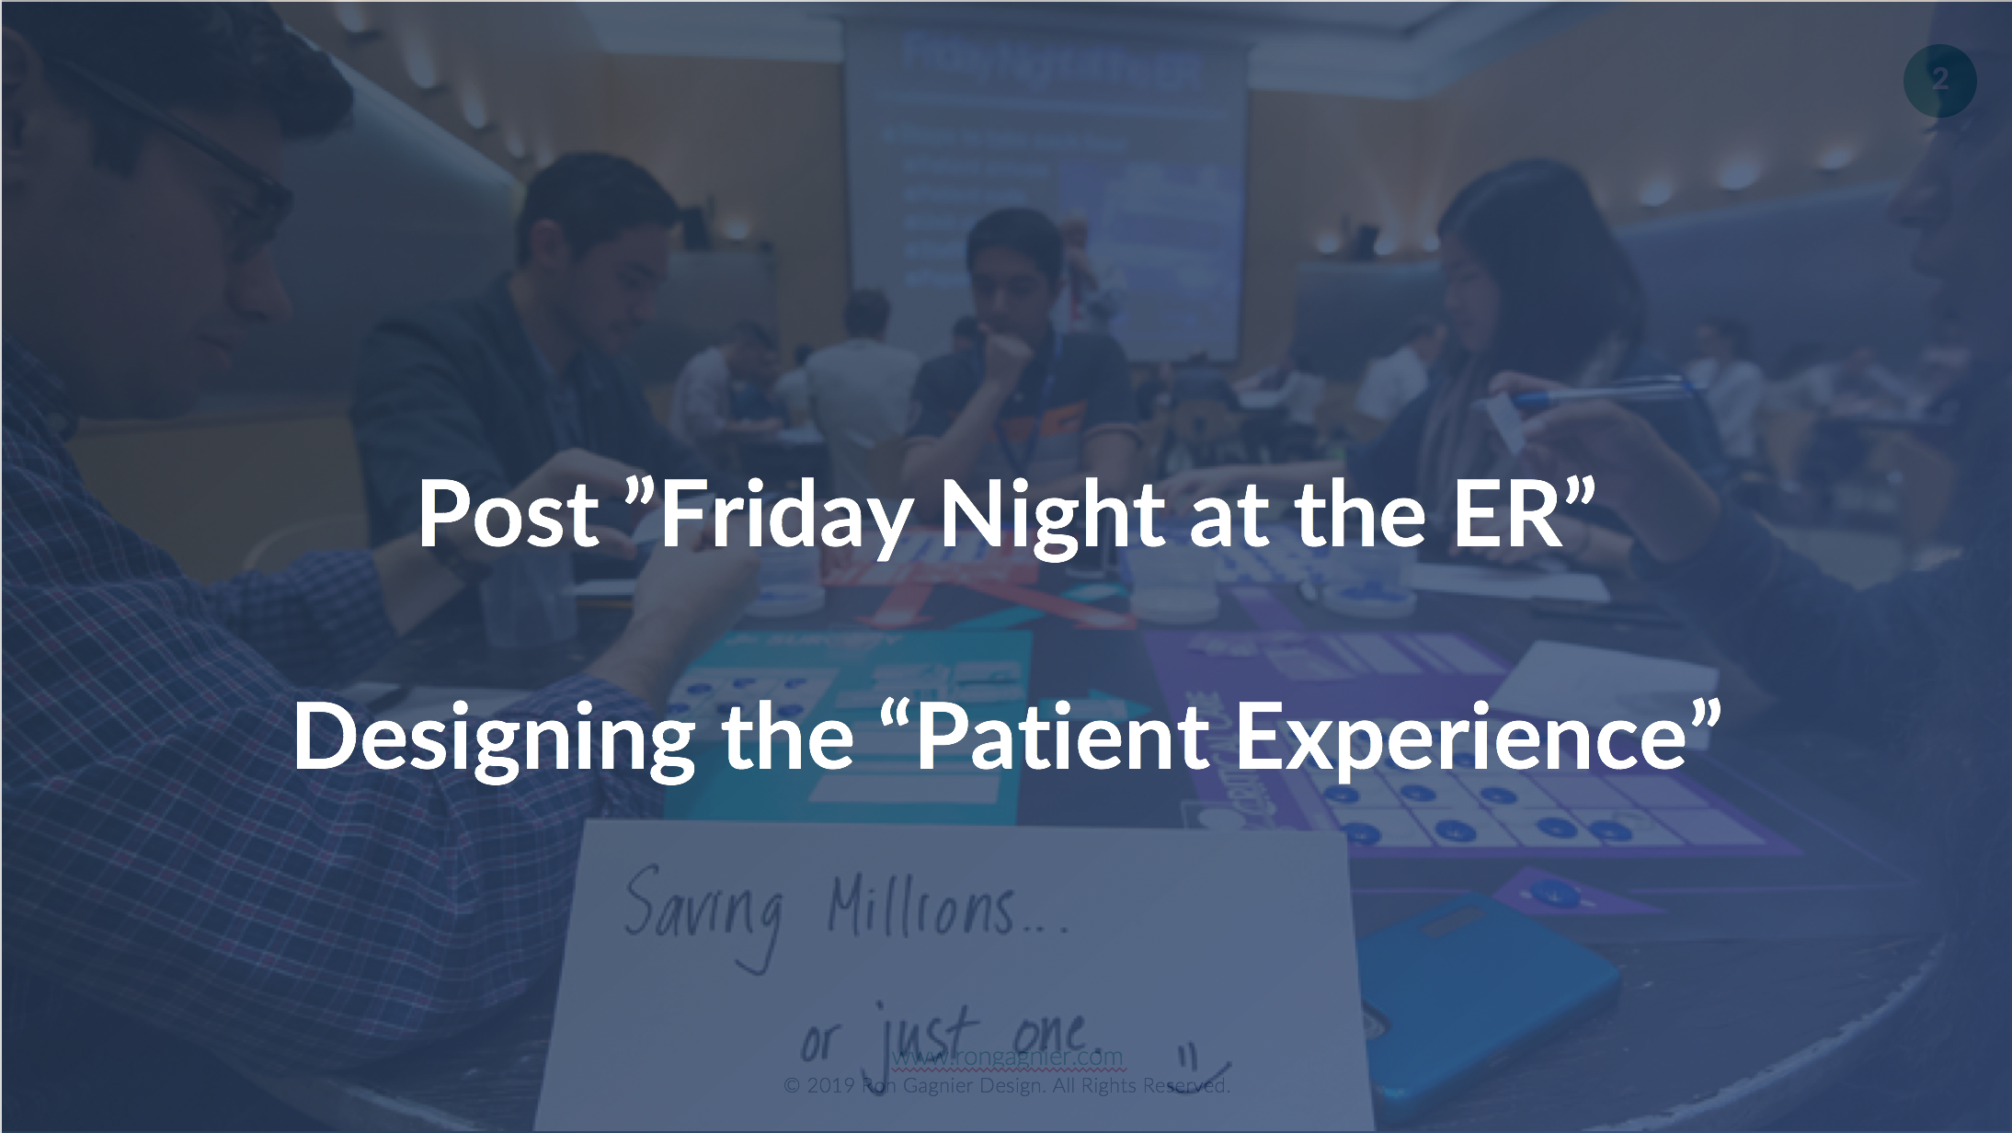

# Instructor Notes:

From the “Friday Night at the ER” session you learned about systems thinking, which is about seeing how interrelated parts come together to form a system by interacting with one another over time.

During this session we will shift from systems thinking into design thinking. The best way to learn about something is through doing. We will be exploring aspects of design thinking through the same case study, the emergency room. We will focus on the ”Patient Experience” within the emergency and find ways to improve it.

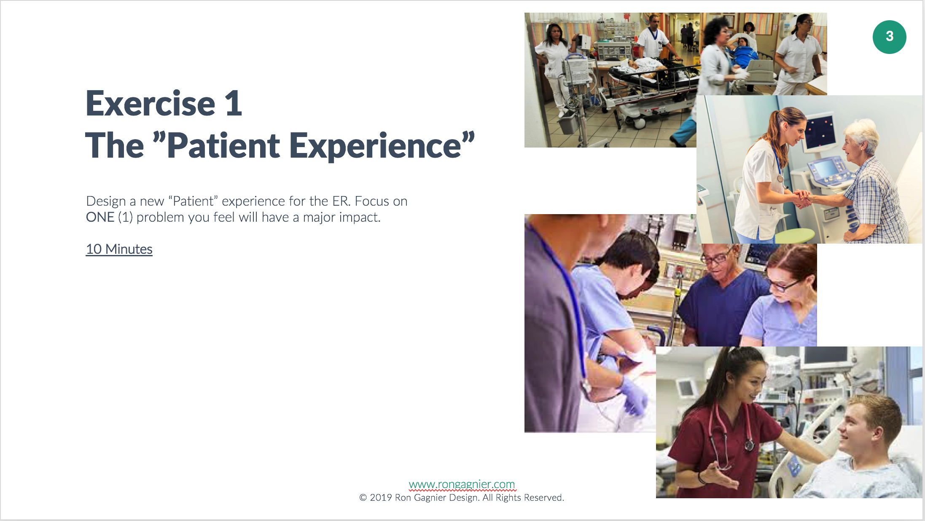

# Instructor Notes:

Independently (on your own). Capture the problem you will focus on and write it down. Now capture a design in any way that conveys how the problem will be solved.

Be prepared to describe both the problem and the solution.

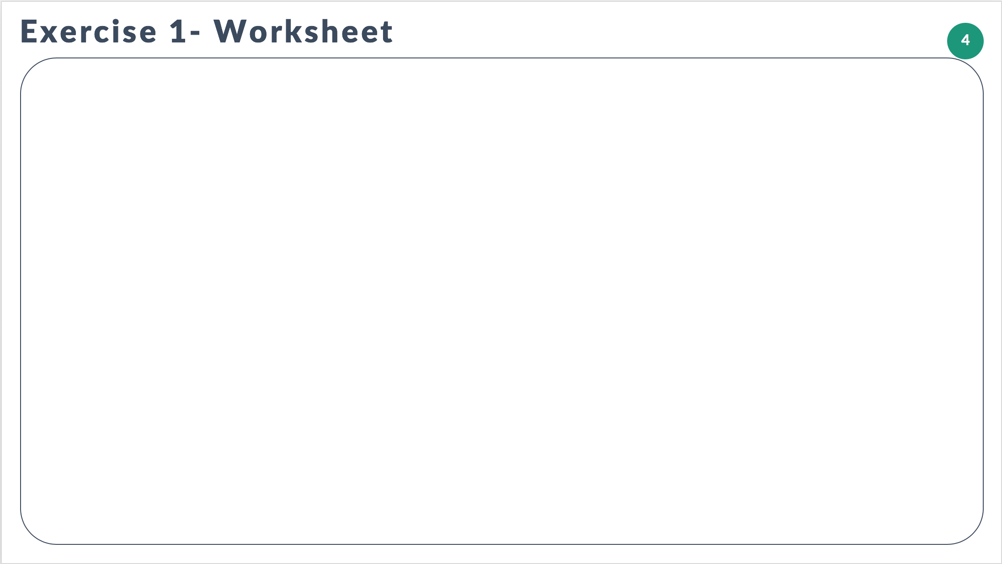

# Instructor Notes:

Write down the problem. Sketch or describe in words a solution to the problem.

Be prepared to describe both the problem and the solution.

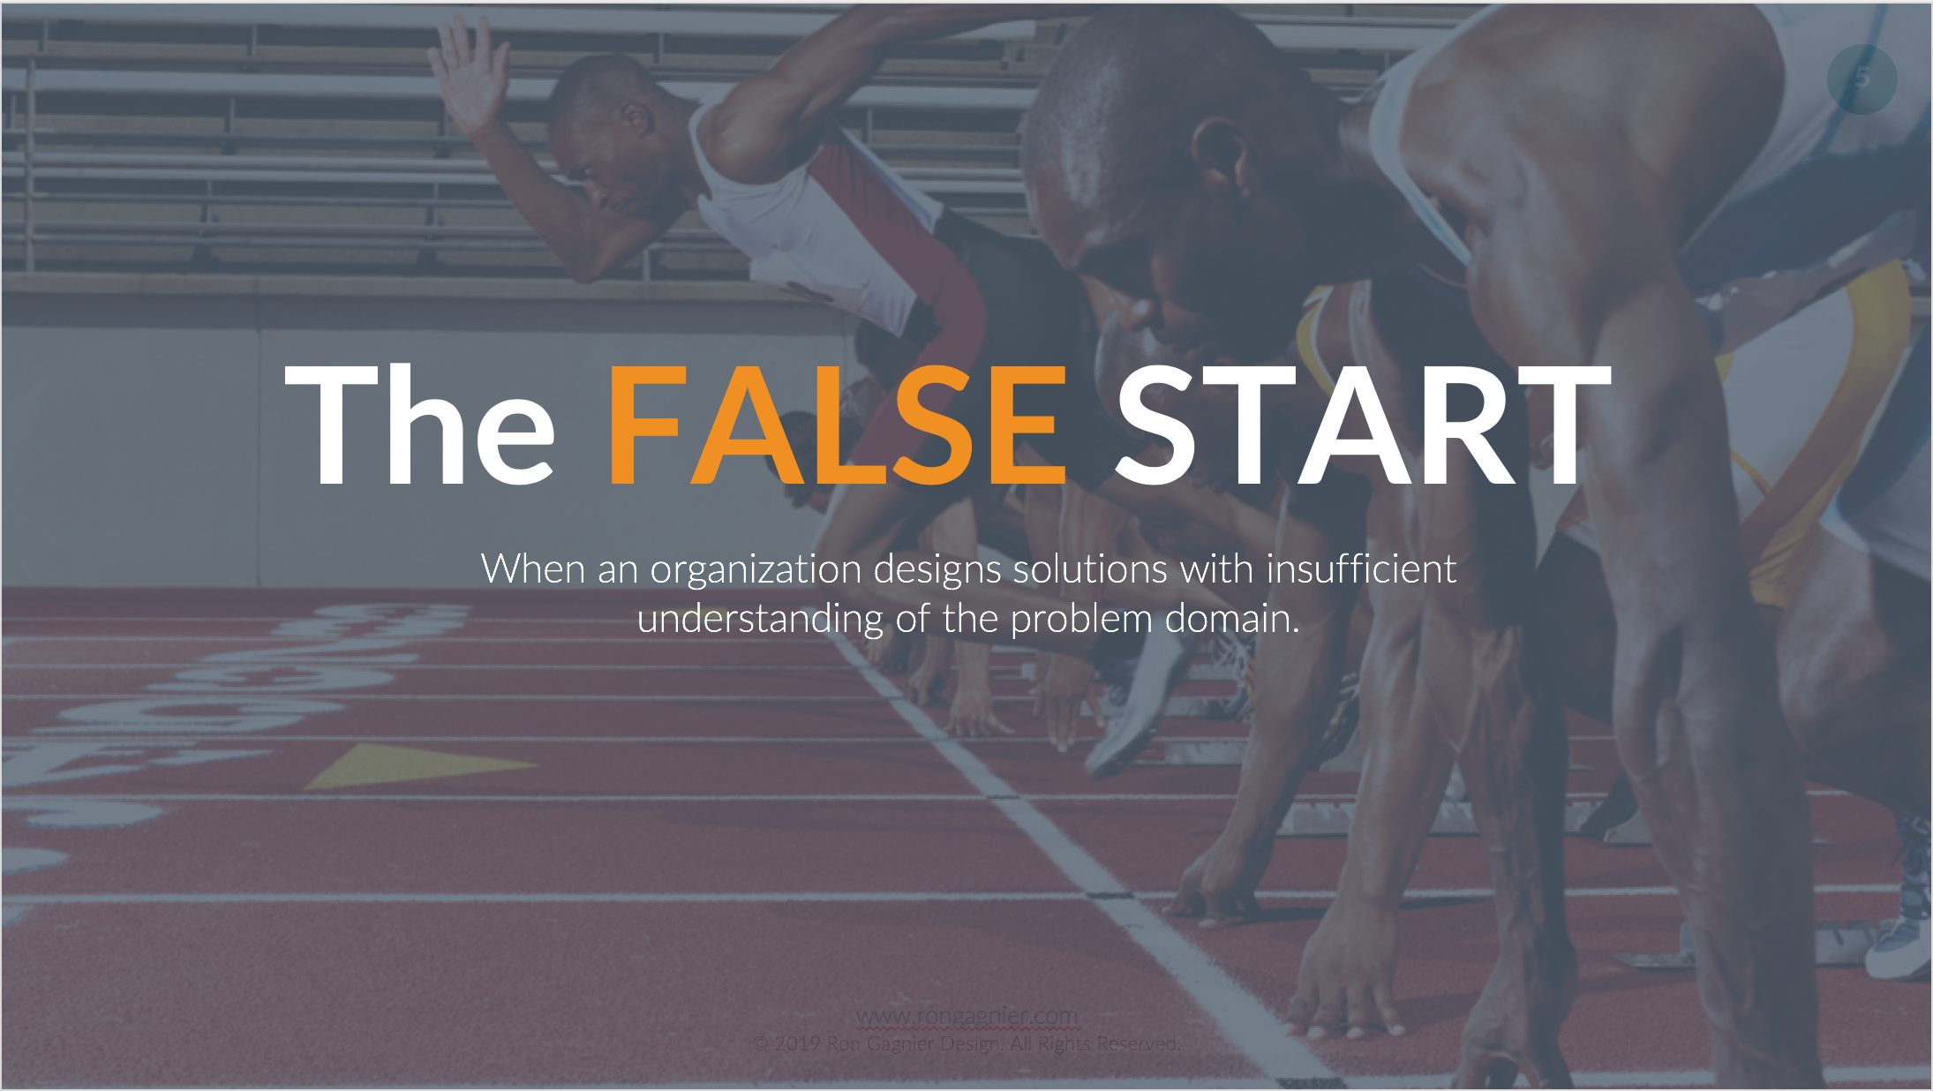

# Instructor Notes:

Typically, **exercise #1** is how most organizations treat projects. Most organizations pick one problem to solve and jump to solutions immediately without a clear understanding of the problem landscape, the scope and impacts of the full range of problems. Without a systematic approach, and a clear understanding of the problem landscape, organizations jump to quickly to solutions.

Commonly known as the “False Start” in design circles. Watch for symptoms of the false start in your projects. Symptoms include:

* “But we already have the technology it will just need to be repurposed…”
* “Our team has already started on a solution, we can’t just throw it away…”
* “Research will just slow us down…”
* “We have an expert on staff who knows about this problem

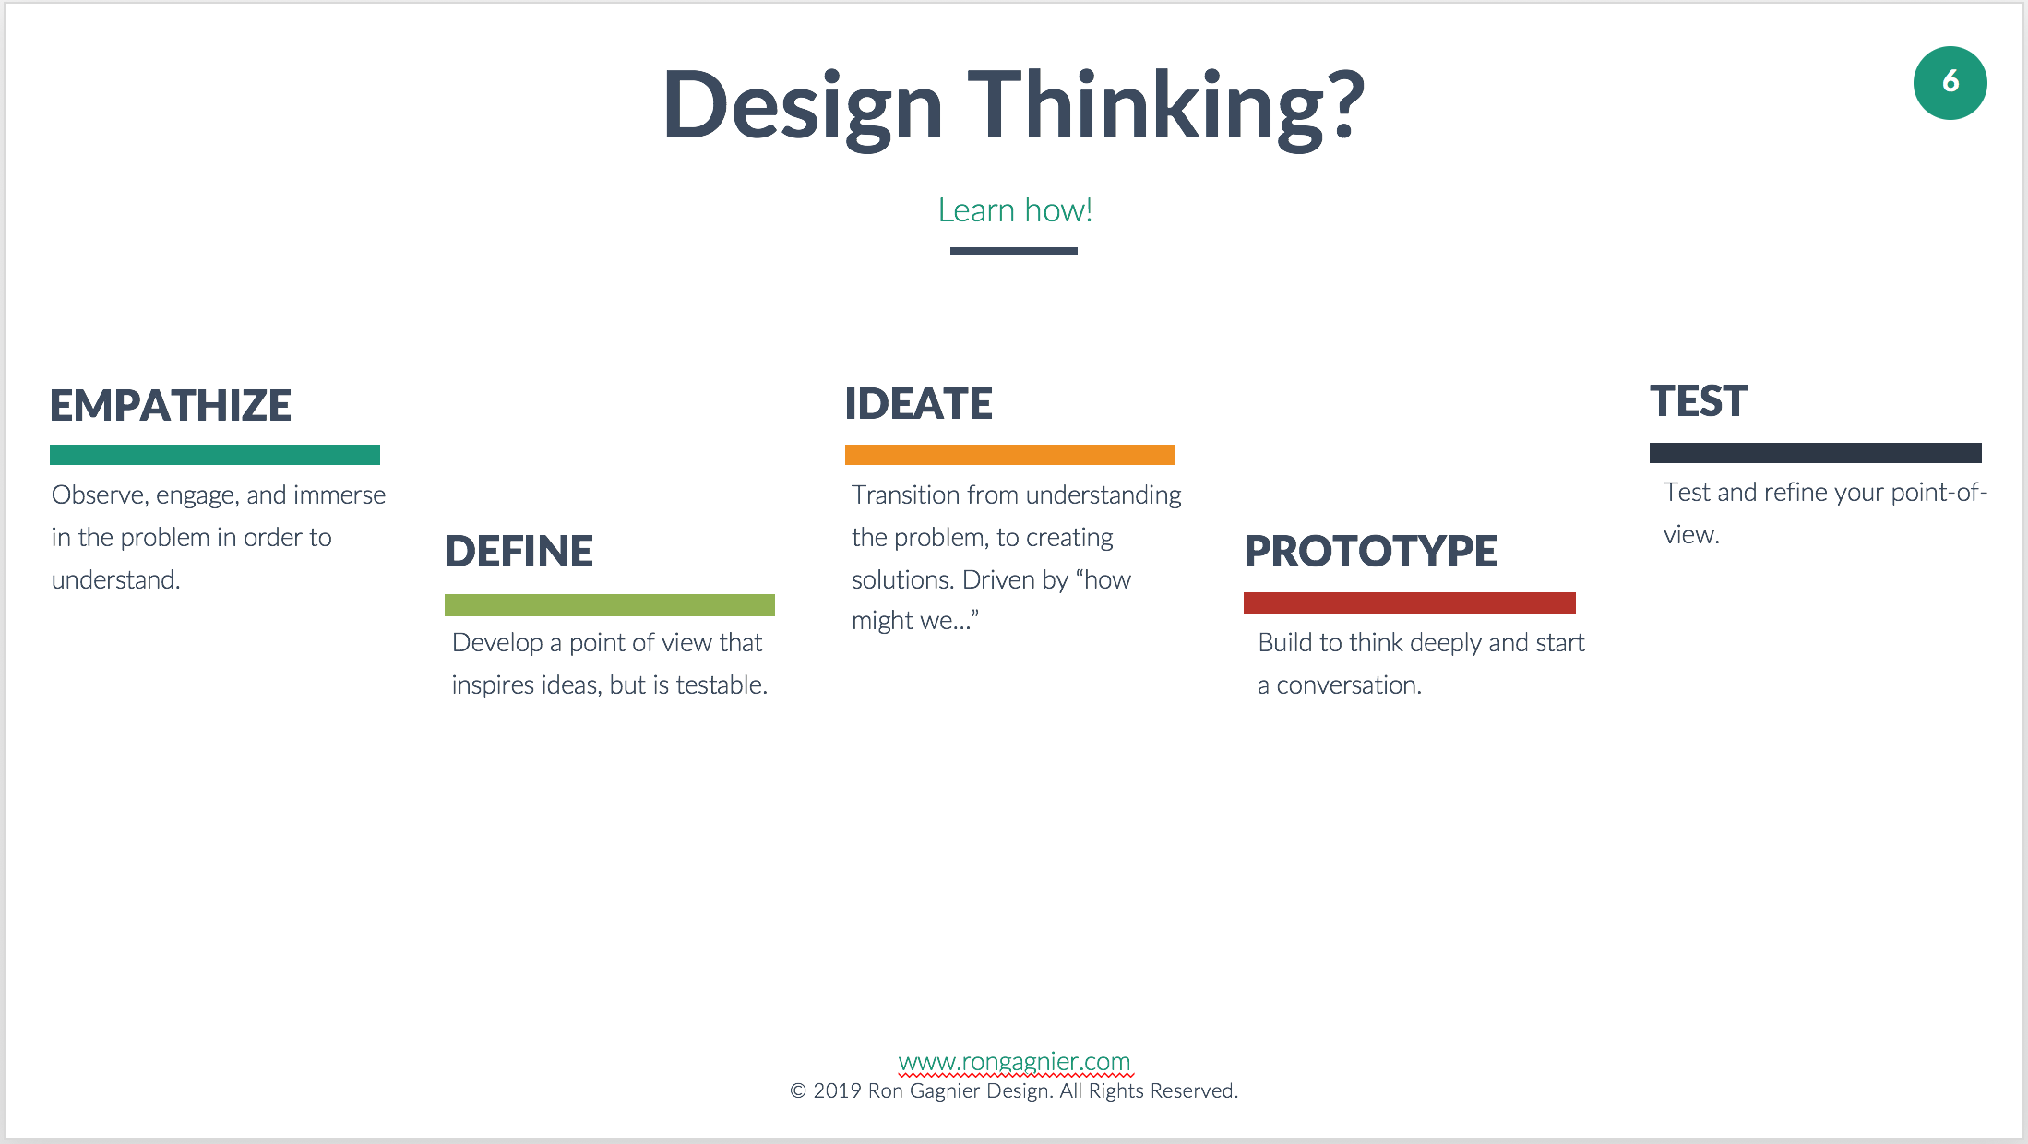

# Instructor Notes:

Design thinking is a system devised to help us overcome our own human bias’s:

* To jump to solutions.
* To make decisions based on incomplete data.
* Towards immediate action.
* Towards inaction (keep analyzing)

Design thinking can help us be mindful to empathize, define, ideate, prototype, and test our ideas, preventing us from jumping to an immediate solution.

For those who want to learn more here are some links:

<https://dschool.stanford.edu/resources/design-thinking-bootleg>

<https://www.ideou.com/pages/design-thinking-resources>

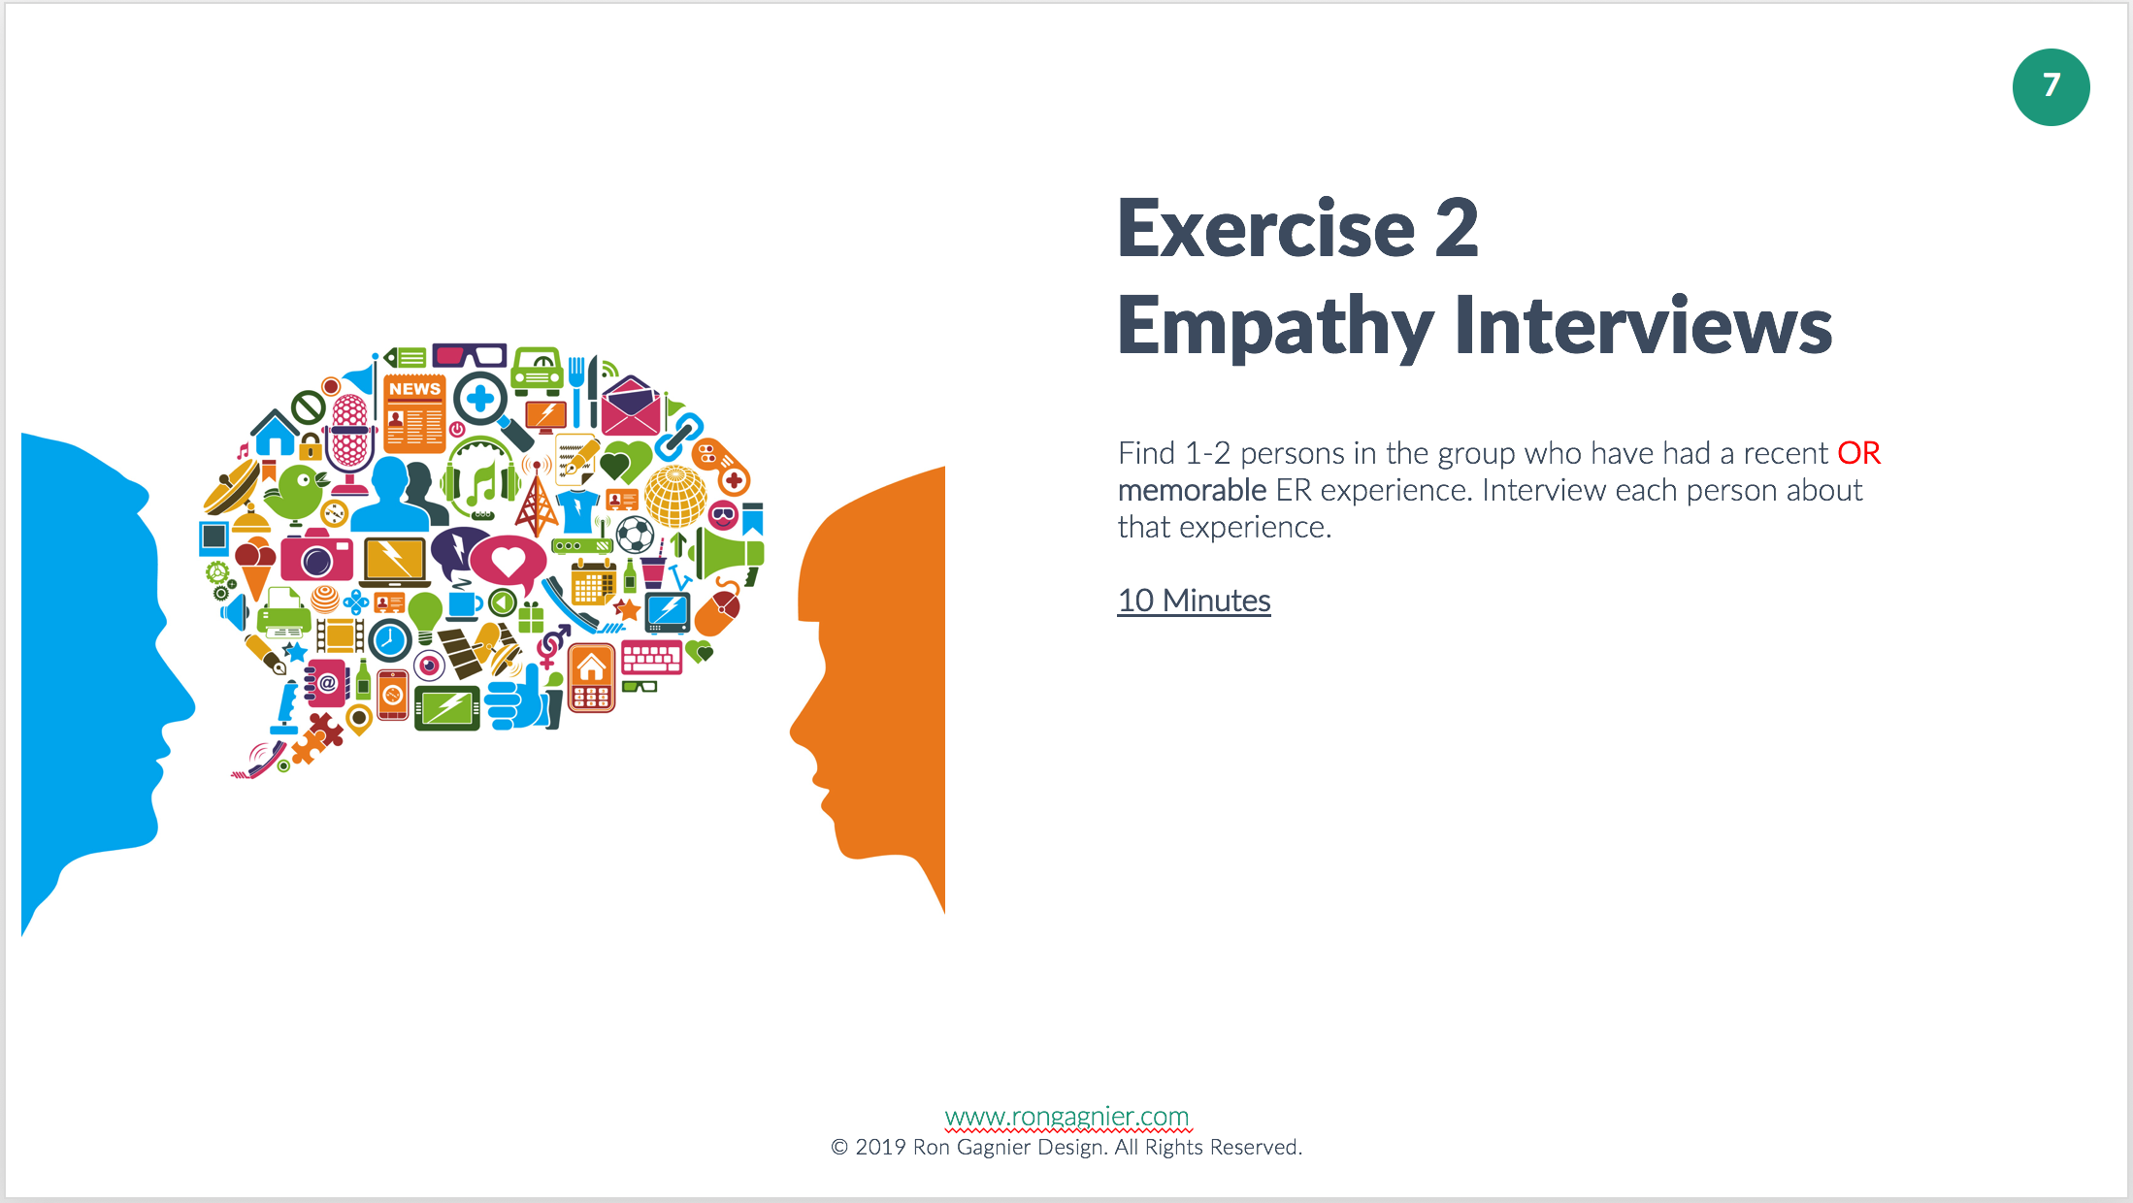

# Instructor Notes:

Empathy is learning how another person feels. I like to say we are putting ourselves in another’s shoes, to try to see things through their eyes. Deep understanding starts with empathy, and empathy starts with listening.

For those who want to learn more about using empathy in design:

<https://www.youtube.com/watch?v=Z33WbbDFjg0>

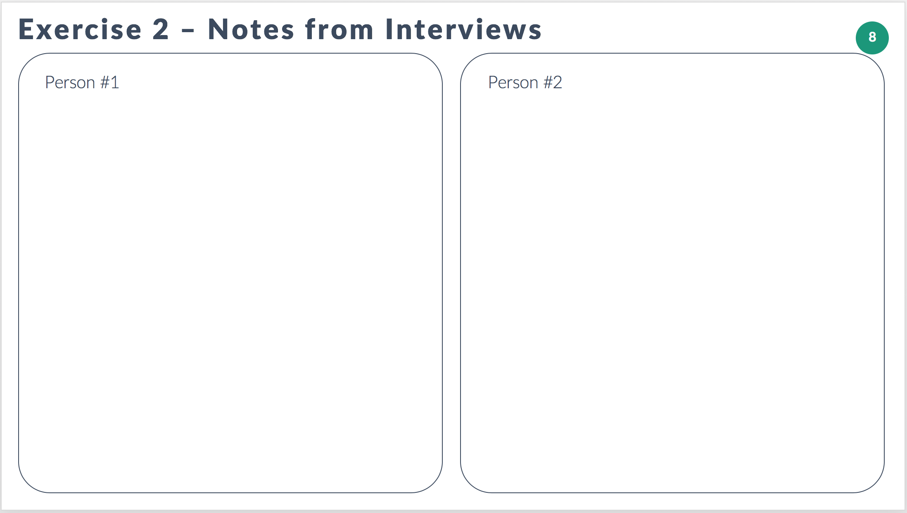

# Instructor Notes:

Sample questions:

Tell me about your experience at the Emergency Room?

How long ago was it?

What type of problem were you facing?

What prompted you to feel the Emergency Room was your best choice for care?

How would you describe your experience at the ER?

Were you satisfied with the outcome of your visit?

Were you satisfied with the treatment you received?

Were you satisfied with the overall experience?

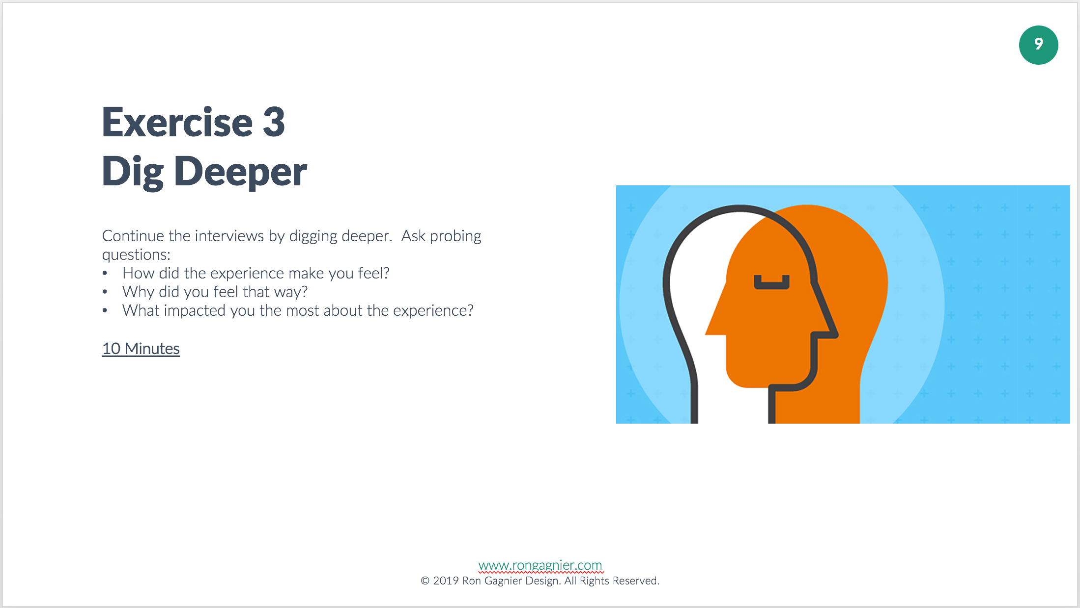

# Instructor Notes:

It is not enough to simply know how a person feels, it is important to understand why?

Only by digging deeper can one truly understand a problem. I suggest that you can’t get to the true reason a person feels a certain way until you have asked them why 3 times. The importance of (3) three whys, is this; most people will provide the superficial answers unless you keep probing.

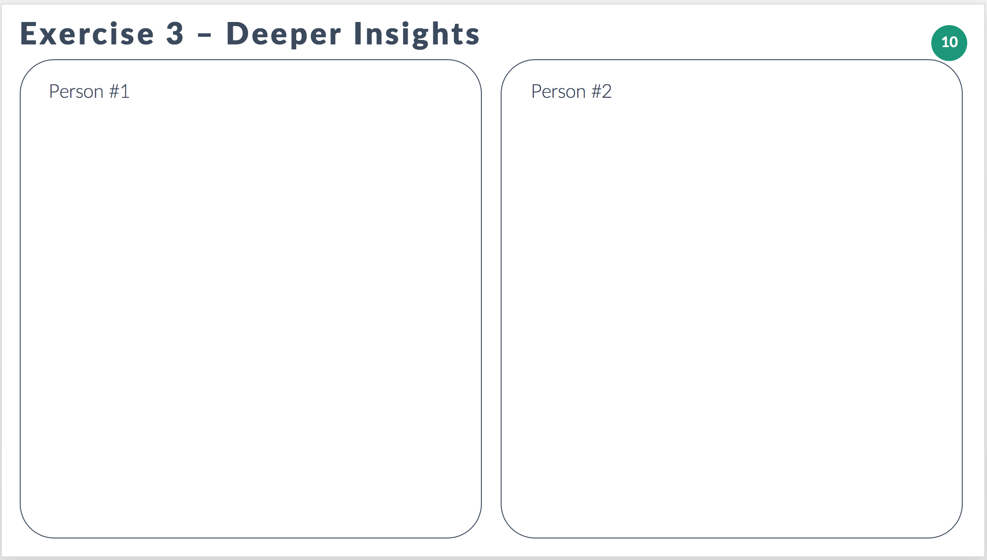

# Instructor Notes:

Sample questions:

What prompted you to feel the Emergency Room was your best choice for care?  Why?

How would you describe your experience at the ER? Why do you feel that way?

Were you satisfied with the outcome of your visit? Why do you feel that way?

Were you satisfied with the treatment you received? Why do you feel that way?

Were you satisfied with the overall experience? Why do you feel that way?

What was the day like for you before you got to the Emergency?  
What was the ambiance like at the Emergency?  
What was your emotional state like when you got to the Emergency?  
Was this the first time you visited Emergency?

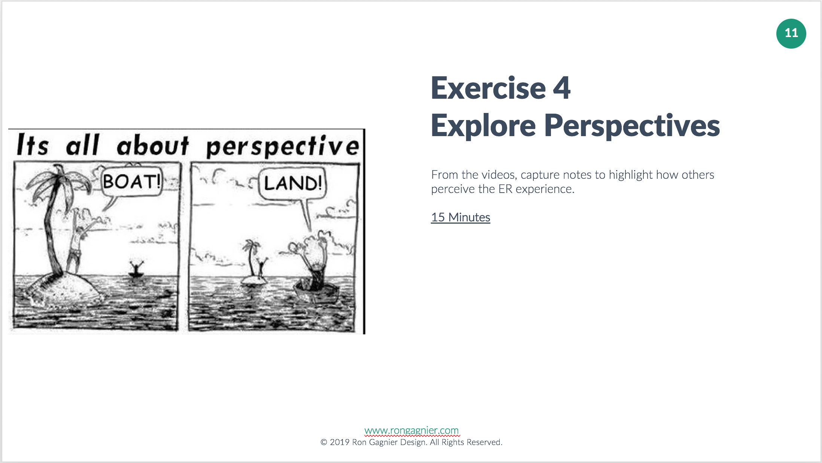

# Instructor Notes:

Everyone has a perspective. Sometimes perspectives can be at odds with one another.

What experiences, and knowledge contribute to that perspective? The key to understanding a perspective is understanding context.

Next I will be showing a few videos that provide different perspectives on the ER experience.

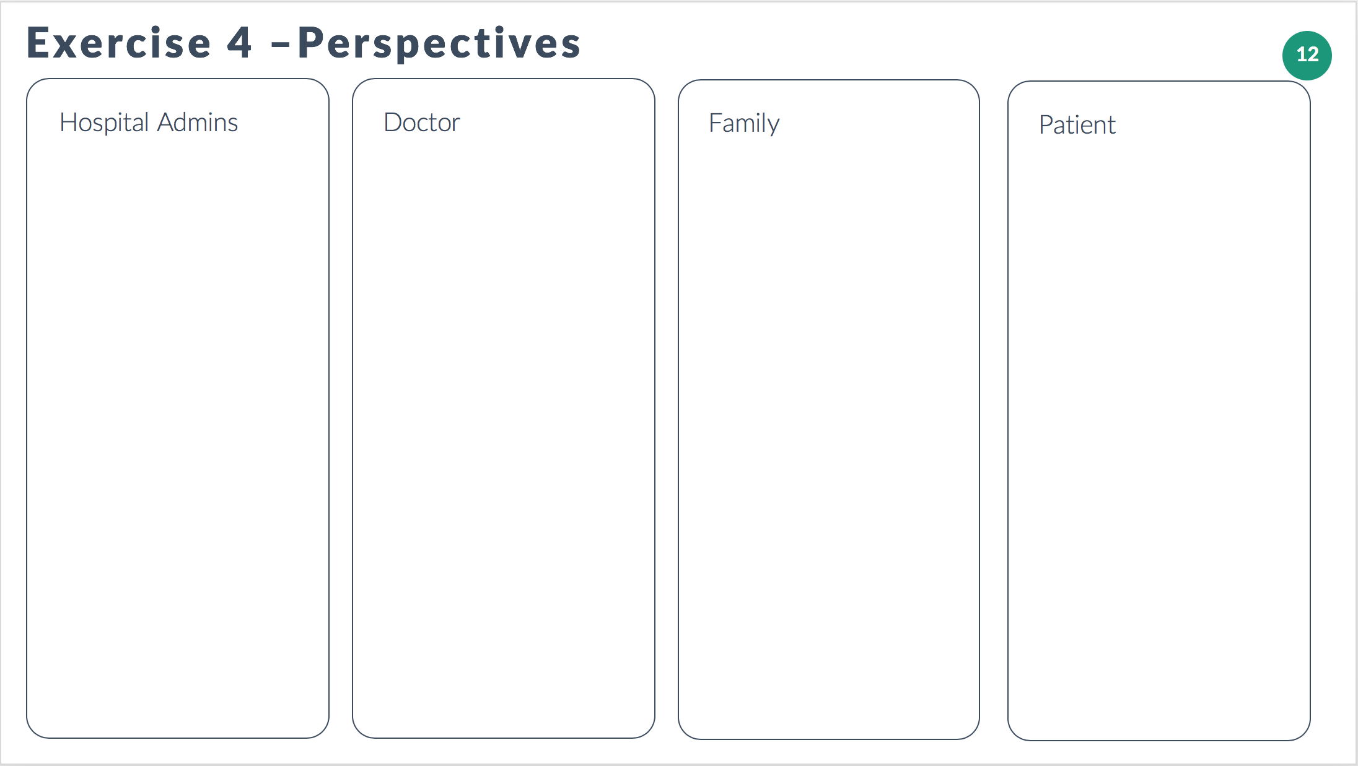

# Instructor Notes:

For each perspective please capture:

What do they consider important for the ER experience?  Why?

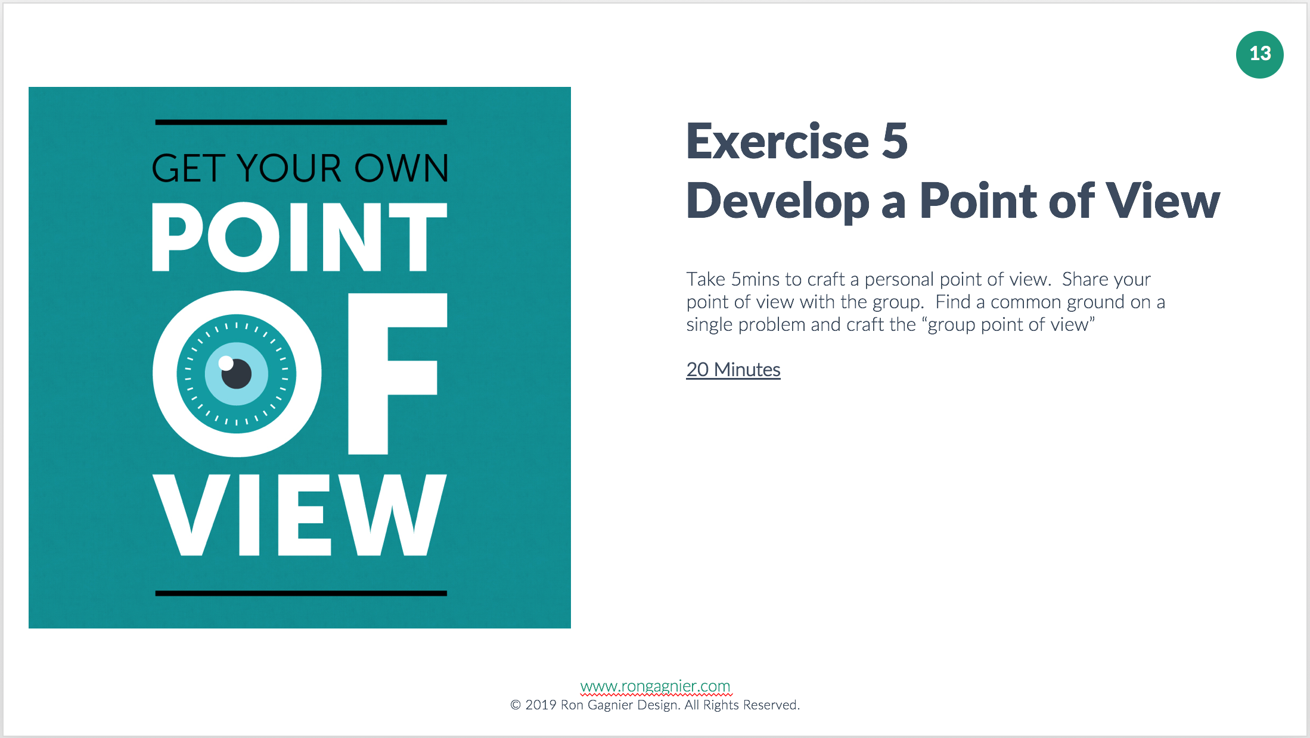

# Instructor Notes:

A point of view is a technique to help make the problem actionable. It is important to define the problem in a way that is actionable in order to allows us to generate ideas for solutions easier.

Want to learn about other ways to develop a point of view?

<https://www.youtube.com/watch?v=TNAdanuvwtc>

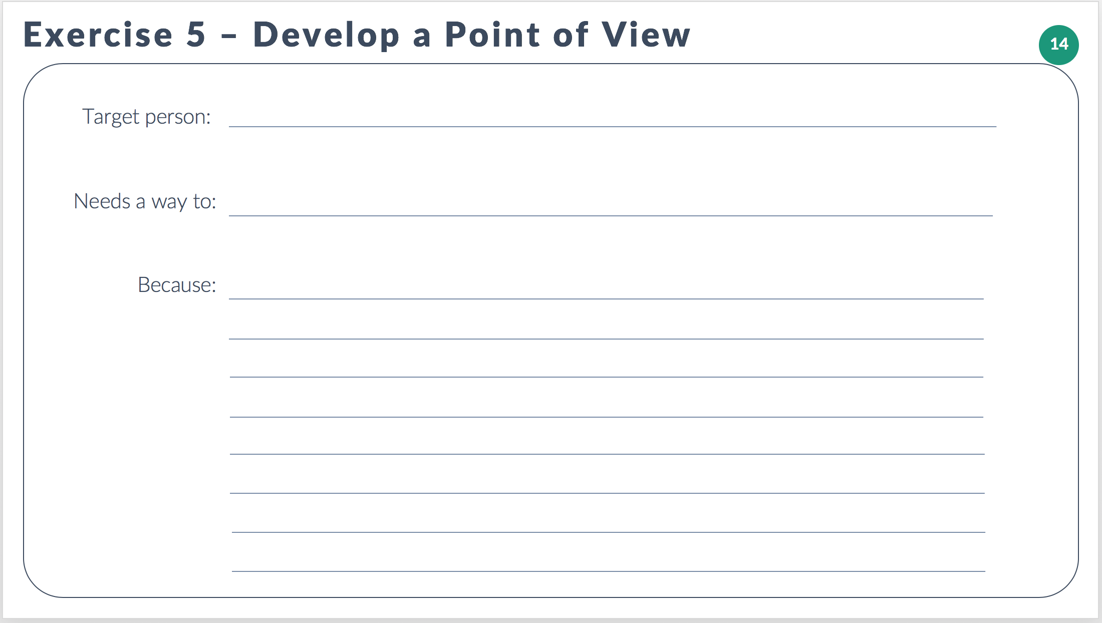

# Instructor Notes:

Who were you speaking with?

What do they need a way to do?

Why do they need that?

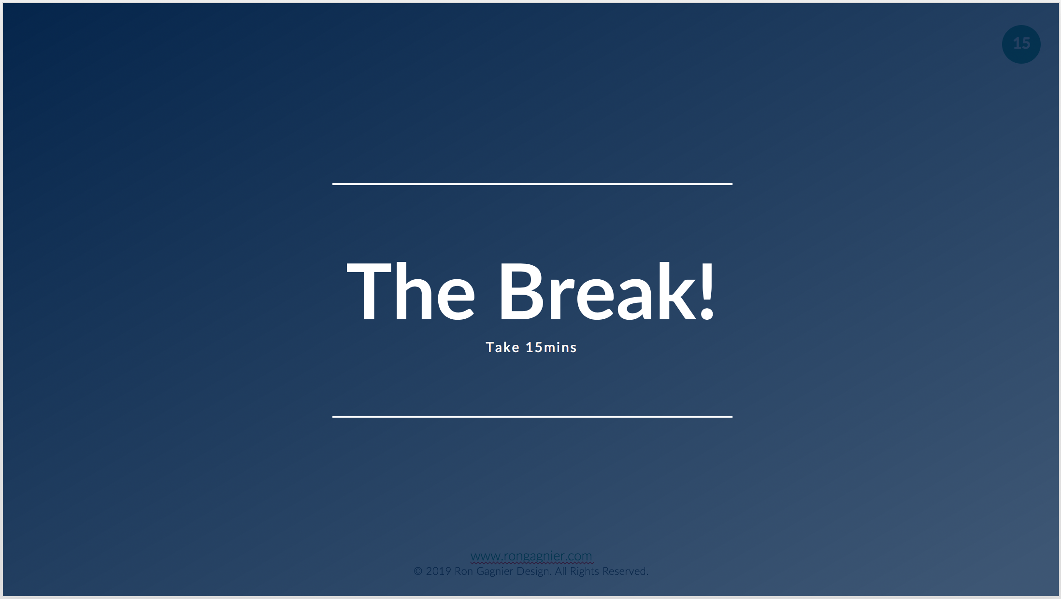

# Instructor Notes:

Design is hard work. Make sure you take breaks during your own design sessions. It is important to stay hydrated, eat a healthy snack, take breaks and move around. Movement gets the blood & ideas flowing!

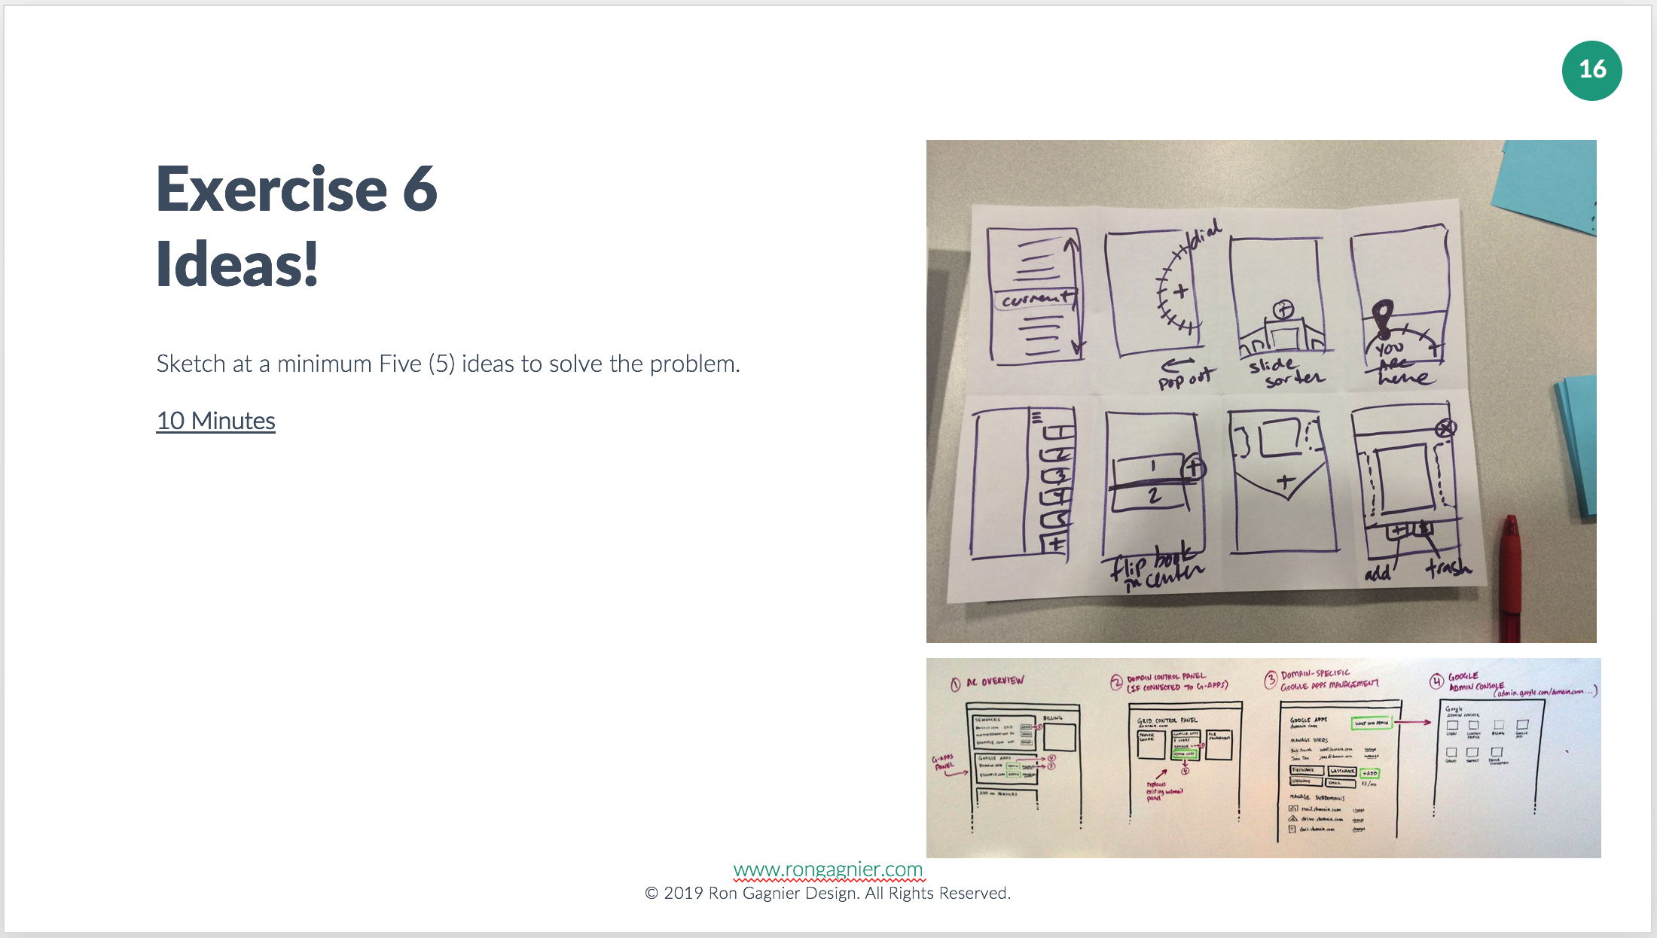

# Instructor Notes:

So often people tell me, “I can’t draw, so I can’t design”. To which I reply, “I can’t draw either”. Sketching solutions does not require an ability to draw or any other artistic skills. Most ideas can be illustrated with basic shapes, arrows and a few words.

Want to learn more:

**Crazy 8’s**

<https://www.youtube.com/watch?v=yz4g87XapQ0>

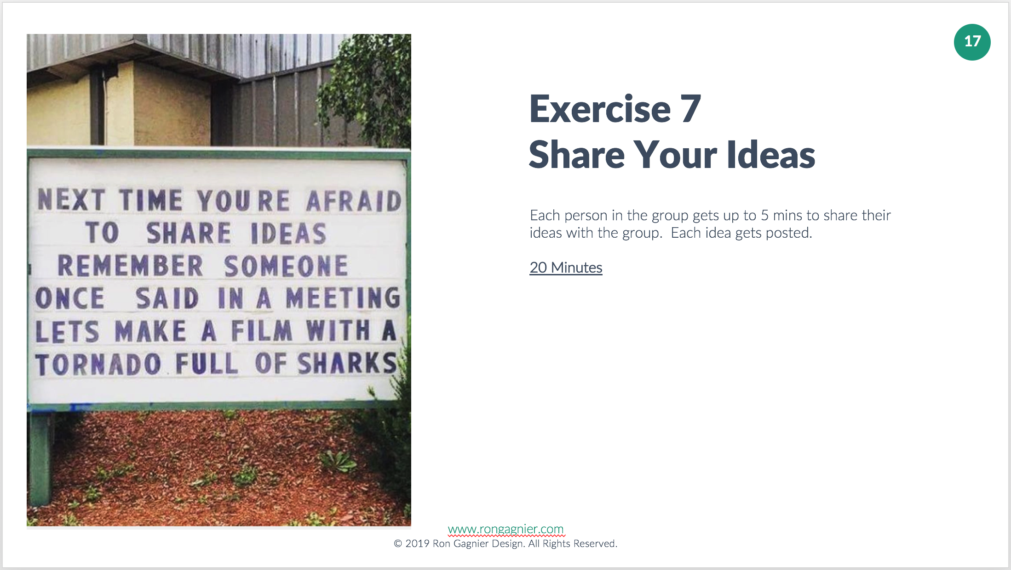

# Instructor Notes:

While others are sharing their ideas you often will get inspiration with new ideas. The best way to capture those is using a technique called “How Might We”. On a post-it note write HMW on the top left corner.

Then capture the idea as a question:

How might we:

“use imagery to direct ER patients where to go?”

“better triage ER patients as they arrive at the ER?”

Want to learn more:

**How Might We in action:**

<https://www.youtube.com/watch?v=sRGk5oKXgCk>

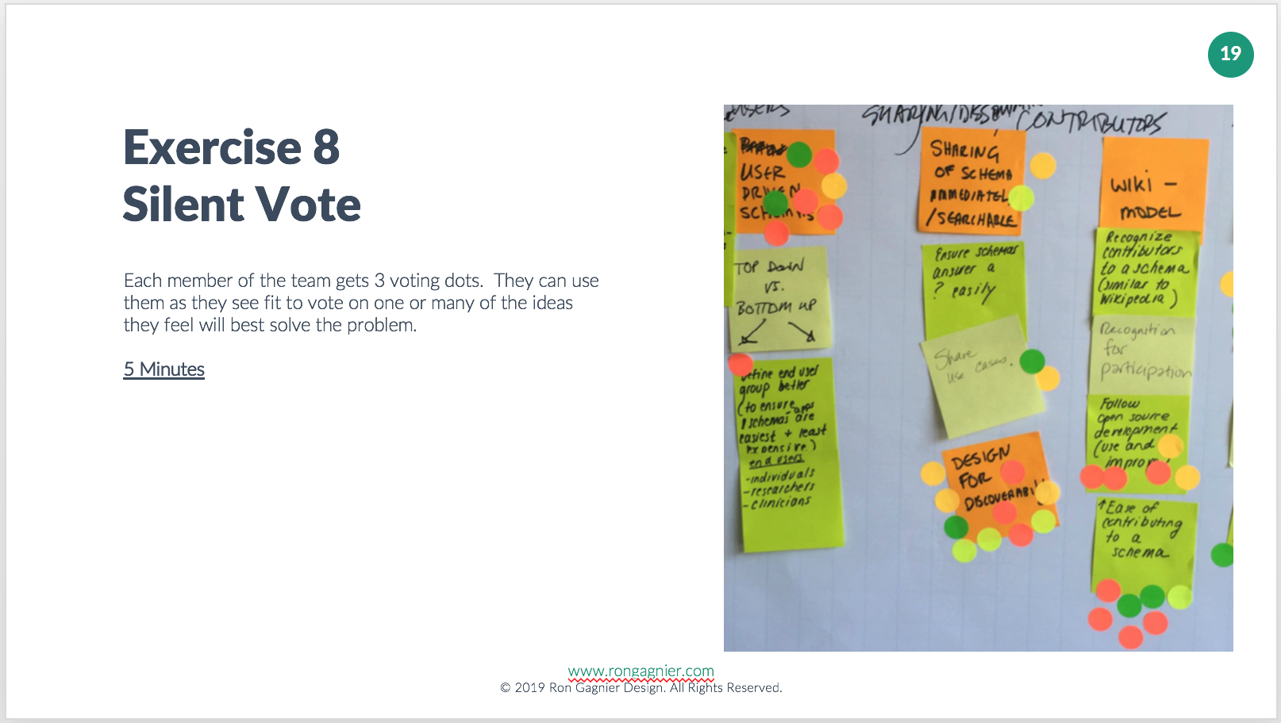

# Instructor Notes:

A silent vote is one of the best ways to gauge buy-in for ideas. Without the need to discuss the merits of one idea over another, everyone votes using stickers for the ideas they feel have the best chance of solving the problem. You can apply all of your votes to a single idea, or spread your dots around to separate ideas. Remember this vote is silent, no need to describe why you voted a certain way.

See it in action:

<https://www.youtube.com/watch?v=GLYqH3xjKLk>

<https://www.youtube.com/watch?v=cfOHlebw2qA>

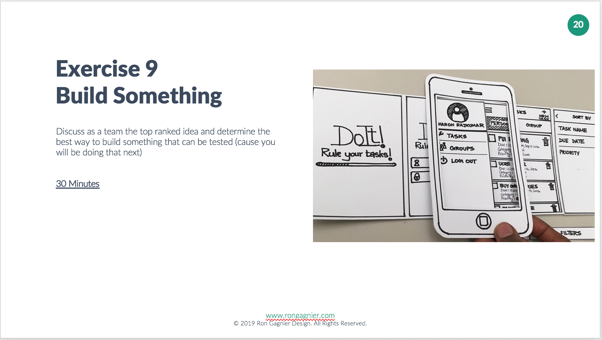

# Instructor Notes:

Don’t get caught up with the aggressive time period.

Nothing has to be perfect.

Build something.

Build anything.

Could be a scenario with a couple of pictures.

Could be a role play where your team acts out a situation with a participant.

Could be a paper-based system, where someone plays the role of any needed technology.

Want to learn more:

<https://www.youtube.com/watch?v=JMjozqJS44M>

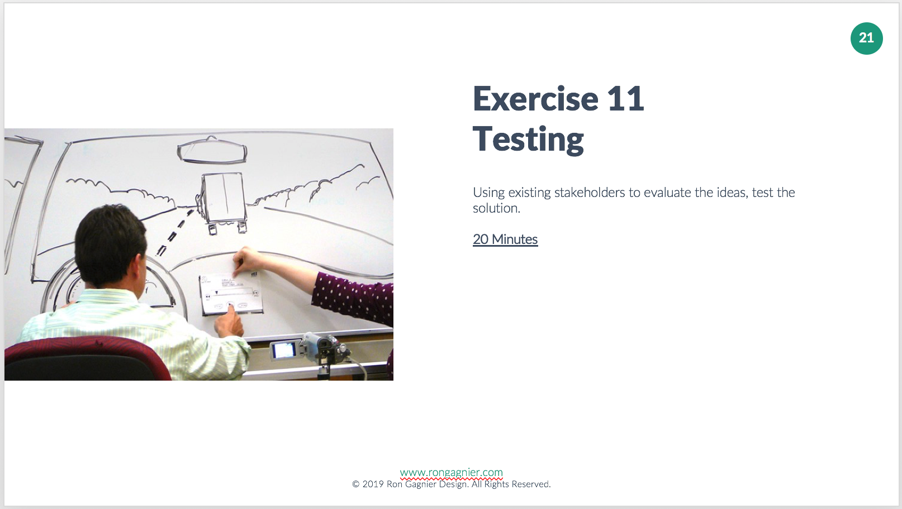

# Instructor Notes:

Use as test subjects the first two(2) people who had an recent ER experience that your group interviewed?

Testing approach:

“Today we will be exploring a way to improve the ER experience for you the patient.

We’d like to get your feedback on an early prototype.”

Things to try during testing:

Ask the Testing Participant to perform an action

Ask the Testing Participant for feedback (What do you think of X?)

Ask them to compare this prototype to the existing solution.

Ask them if there is anything they can suggest to improve the prototype.

Want to learn more about testing:

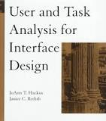<https://www.amazon.ca/User-Task-Analysis-Interface-Design/dp/0471178314>

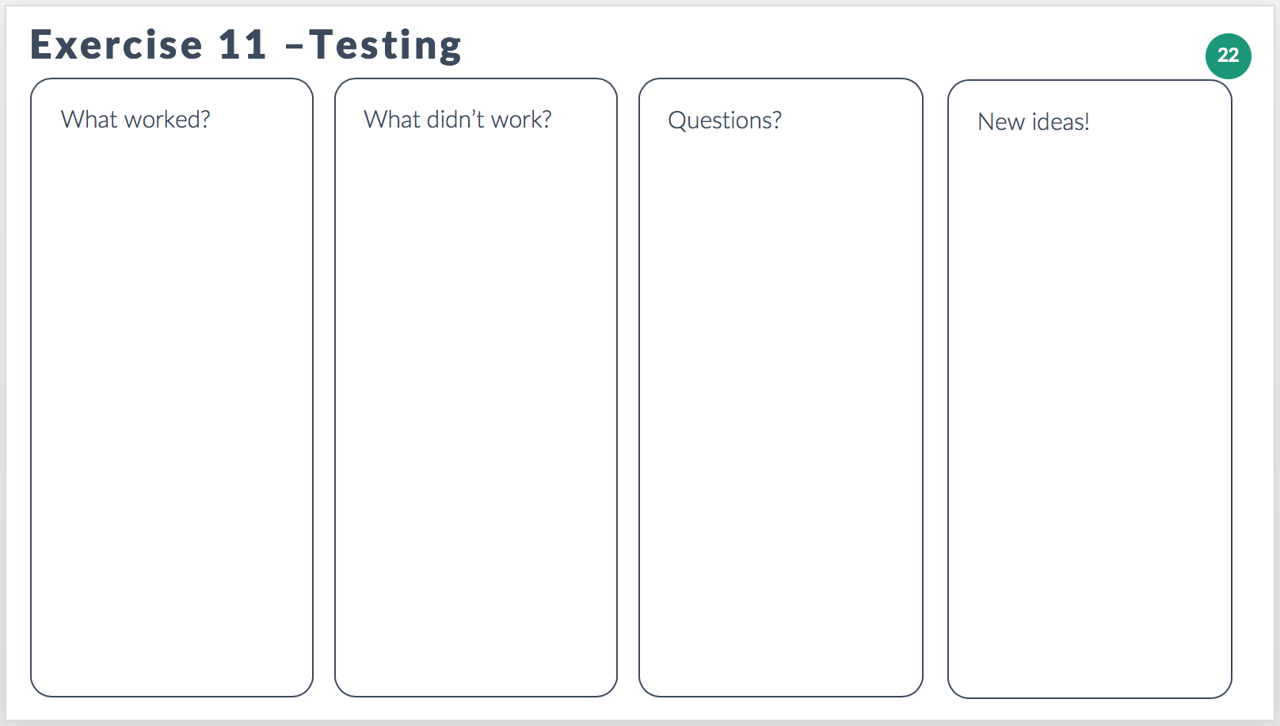

# Instructor Notes:

Testing a prototype should answer the vital question did the idea solve the problem, however answers are seldom definitive. Sometimes part of the prototype worked, and other parts didn’t. It’s important to capture both. Sometimes prototypes raise new questions about the user, the problem and the possible solutions. Capture those to know what questions need answering next. Sometimes prototypes get used in ways that lead to new ideas. Capture those ideas they may lead to a better solution.

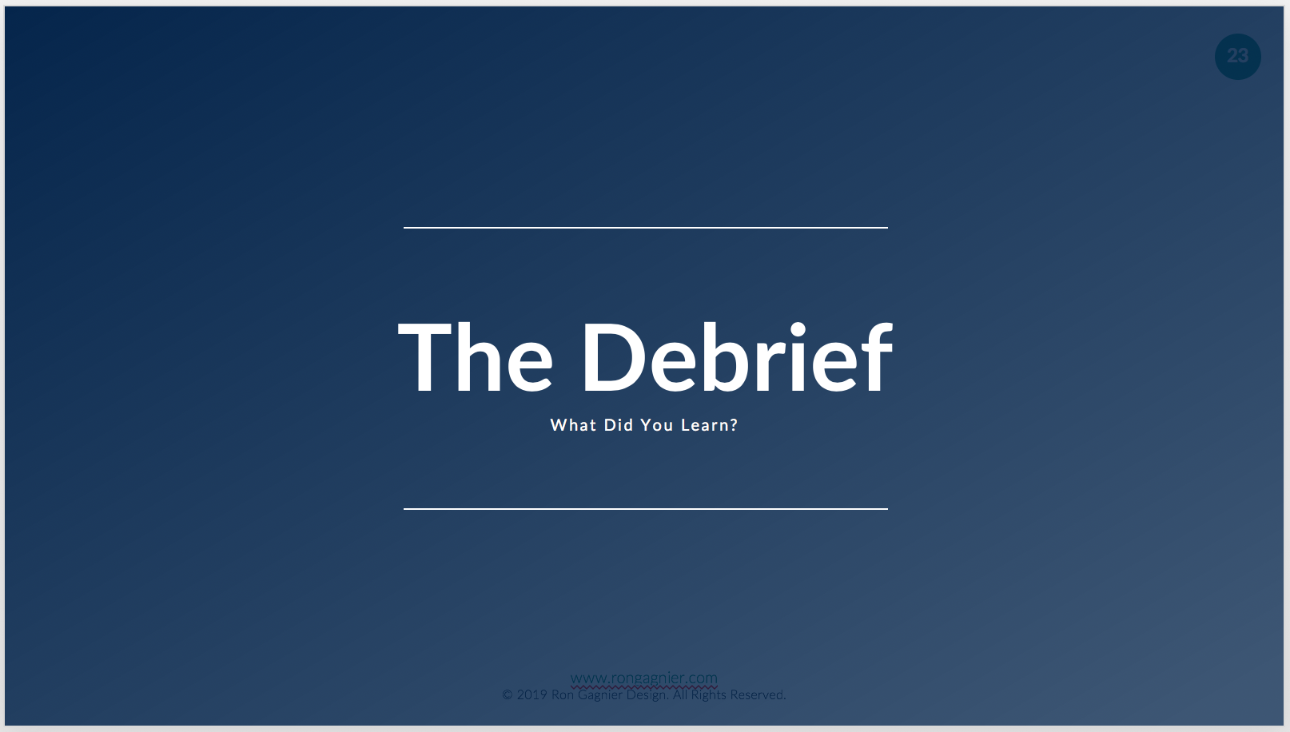

# Instructor Notes:

What did we learn?

Design isn’t a person. Design isn’t an outcome.

Design IS a set of activities performed by a team.

Design IS about communication.

Design IS about understanding.

Design IS about ideas.

Design IS about people.

Design thinking can spur innovation.

Design thinking can be fun.

Design thinking IS for everyone, because design is a team sport.